**AMERICAN INTERNATIONAL UNIVERSITY–BANGLADESH (AIUB)**

**FACULTY OF SCIENCE & TECHNOLOGY**

**Spring 2022-2023**

**Section: J, Group:6**

**LAB REPORT: 02**

**Supervised By: SADMAN SHAHRIAR ALAM**

**Date of Submission: 11.02.2023**

**Submitted by: Sirajus Salehin(ID:21-44543-1), Group 6**

**Title:** Study of signal frequency, spectrum, bandwidth, bit rate, quantization using MATLAB

**Abstract:**

Different MATLAB operations and functions will be performed in this experiment. The purpose of this experiment is to study the signal frequency, spectrum, bandwidth, bit rate, and quantization using MATLAB and develop an understanding of the MATLAB environment, commands and syntax as well as how to use it to solve communication engineering problems. The experiment was conducted using MATLAB software. All the objectives were successful. It helped us with a better understanding of the MATLAB environment and command and syntax usage.

**Performance Task:**

My ID: 21-44543-1 = AB-CDEFG-H

So, A1= GD=3*4=12

A2= AF= 2*4= 8

f1= C = 4*10 = 40

**f2= F=4*10 = 40**

**as taking f2=F gives us the same frequency we’ll take the next letter for calculation which is G=3**

**so we get f2= G= 3*10=30 .**

For X1,

fs= Sample frequency = Highest Frequency*20

t = 0:0.1:1;

X1= A1*cos(2*pi*f1*t)

X2= A2*cos(2*pi*f2*t)

Code:

A1= 12

A2= 8

f1=40;

f2=30;

fs=40*20

t=(0:(1/fs):1)

x1 = A1*cos(2*pi*f1*t)

x2 = A2*cos(2*pi*f2*t)

x3 = x1 + x2

figure('name','Performance Task of DC Lab 2');

subplot(4,1,1)

plot(t,x1,'r')

xlabel('Time')

ylabel('Amplitude')

title('X1')

subplot(4,1,2)

plot(t,x2,'m')

xlabel('Time')

ylabel('Amplitude')

title('X2')

subplot(4,1,3)

plot(t,x3,'g')

xlabel('Time')

ylabel('Amplitude')

title('X3')

N1 = length(x3)

N2 = 2^nextpow2(N1)

fx3 = fft(x3,N2)

ffx3 = fx3(1:N2/2)

xfft = fs*(0:N2/2-1)/N2

subplot(4,1,4)

plot(xfft,abs(ffx3),'k')

title('fast fourier transform of the X3 signal')

xlabel('Frequency (Hz)');

ylabel('magnitude');

**Bandwidth = Higher Frequency – Lower Frequency = 40Hz - 30Hz = 10Hz**

**Simulations:**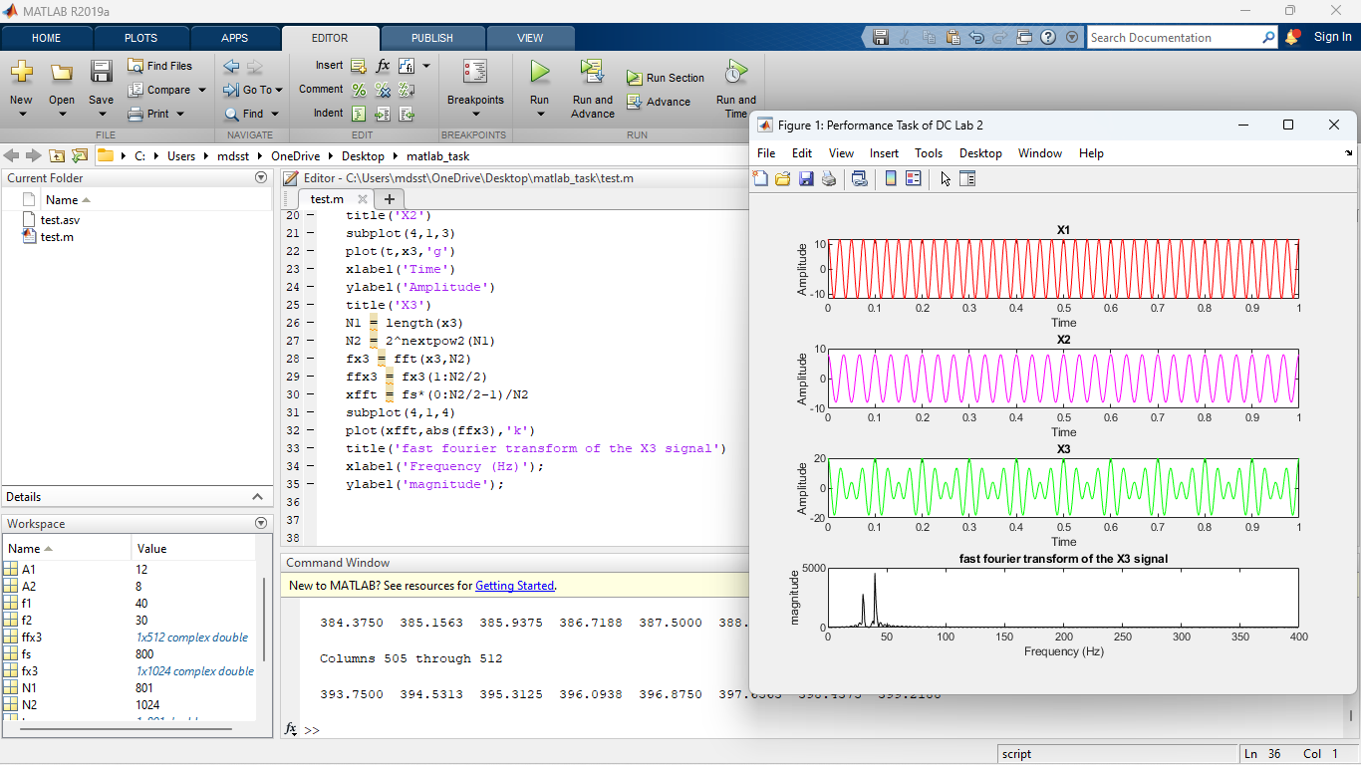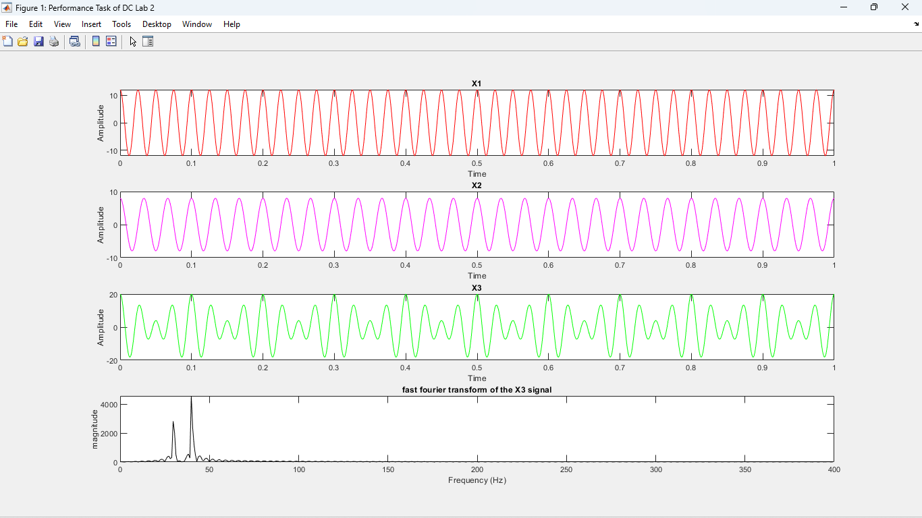

**Discussion:**

As per the objective, different MATLAB operations were performed which helped us with a better understanding of signal frequency, spectrum, bandwidth, bit rate, quantization and the MATLAB environment, commands and syntax as well as its usage to solve communication engineering problems.

**Conclusion:**

The purpose of this experiment was to develop an understanding of signal frequency, spectrum, bandwidth, bit rate, quantization and the MATLAB environment, commands and syntax as well as its usage to solve communication engineering problems. We were able the accomplish all the objectives. In the lab, we had some trouble using MATLAB software, After strictly following the lab instructions, it was resolved. In this experiment, we performed some MATLAB operations, plotting’s, and functions. Perhaps this experiment could be improved by verifying the results using other software and by comparing them. This experiment shows that MATLAB is very essential for solving complex mathematical and data communication problems. It is very easy to use and it saves us a lot of time and its results are very accurate.

**REFERENCE:**

1. MATLAB user guide.

2. AIUB lab manual.

3. Prof. Dr.-Ing. Andreas Czylwik, “MATLAB for Communications”